Roll & Make Whole Directions

Roll and Make Whole practices two skills:
1. Reducing fractions to their lowest terms (i.e. simplifying fractions).
2. Adding fractions (sometimes with different denominators) to equal one.

Supplies
3-page PDF download of the game board and die
3 pages heavyweight cardstock
Different game pieces, one for each player (we used oversized buttons in two different colors)
Scissors (to cut out the die)
Hot glue (to hold the die together)
Tape (to tape the game board together)

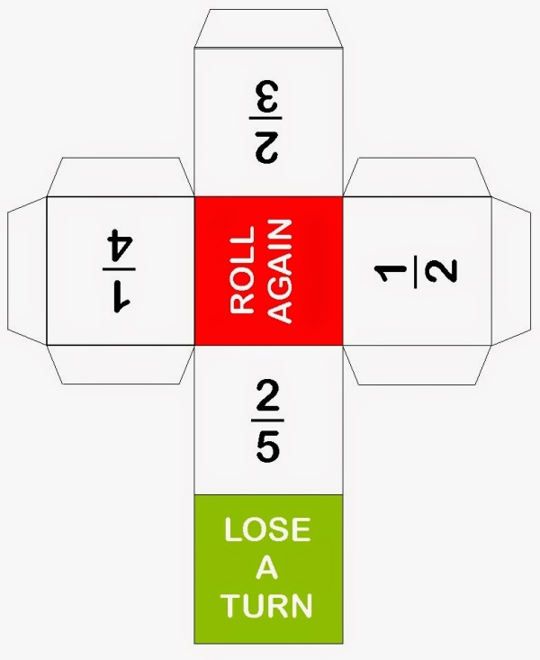

How to Play
All players put their game pieces on the start square. The youngest player rolls first. Whatever fraction is revealed on the top of the die when it stops moving, is one part of a fraction addition problem. For example, if the player rolls a 2/5, they must ask themselves, "what fraction do I need to add to 2/5 to make one whole?"

They'll then look at the board and find the first occurrence of either 3/5 or another fraction that can be reduced to 3/5 (e.g. 6/10 or 9/15).

Their game piece will then be moved to that square. If a player rolls LOSE A TURN, their game piece remains in its place and an opponent gets to roll and move. If a player rolls ROLL AGAIN, they must do as the die says.

When players near the end, they must roll 2/3 to win, as 3/9 is the final square on the board. The first player to arrive at the finish wins.

