Multiplying Domino Fractions

You will need to print the game cards, which you can laminate. You will also need a set of dominoes and two dry-erase markers. Put the doubles aside (i.e. six six, four four, etc.) and turn the rest of the dominoes upside down on the table.

Make desired number of copies of the game cards.

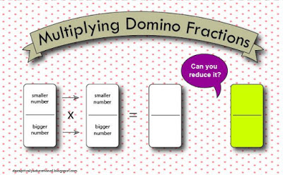
Have the kids draw two dominoes from the pile and placed them on the game card.

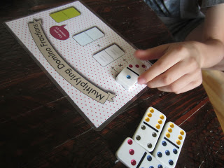

Multiply the numerators and the denominators, writing the numbers on the card with a dry-erase marker. Stumped? Watch this great video from Khan Academy. You can have the kids reduce the fraction to its lowest terms, if appropriate.

Now have the other partner do the same thing. Compare your final answers. Whose fraction was bigger?
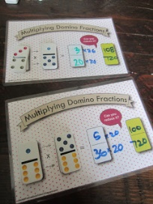

If it's not readily apparent, have the kids look for a common denominator. Confused? Watch another Khan Academy instructional video; this one is great!

The player with the largest fraction takes the four dominoes. With the cards laminated, the dry-erase numbers you add can be wiped clean with a paper towel. The player with the most dominoes in the end wins.

