Prep

The 4-page PDF contains 3 sets of numbered cards (1-10), a spinner to make, and a scorecard.

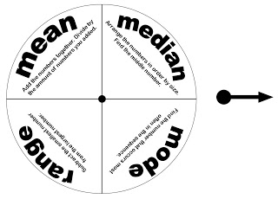

To make the spinner, print the template onto a piece of sticker paper. (Don't have any? Use a glue stick instead.) You can stick it to the brown side of a recycled cardboard cereal box. Then cut it out, punch a hole in the middle of the spinner and the arrow, thread a brad through both and loosely (so it spins freely) separate the prongs on the brad at the back of the spinner.

Print desired amount of sets of numbered cards onto heavyweight cardstock.

Want to save some printer ink? Forego this download and grab a deck of cards. Use aces as 1s, and eliminate the kings, queens, jacks, and jokers. Instead of a spinner, decide which you'll calculate for each round (mean, median, etc.) and use scratch paper for score keeping!

Play
Deal five piles of five cards each face down in front of you and your partner (i.e. you will both have 25 cards in front of you in five even piles).

For each round, take turns flicking the arrow on the spinner. Next, you turn the cards on top of each of the piles over. If the arrow pointed to mean, you figure out the mean (calculator optional).

You then check the box on your scorecard to indicate that Round 1 was mean, write down the two scores (the number resulting from your calculations), and remove the cards from your piles, setting them aside, so you can prepare for Round 2.

After five rounds of play, total your scores. The player with the highest number wins!

