Mean-Median Match-Up

This game practices ordering numbers from least to greatest, addition, division, & greater than/less than.
Supplies
PDF of the die and personal recording cards
Heavyweight cardstock to print the 2-page on
Scissors and glue to cut and put together the 12-sided die
Lamination (or plastic sheet protector sleeves)
Fine-tip dry-erase markers for each player
Prep
Cut apart the personal recording cards (laminate first if doing so). If not laminating, place inside a plastic sheet protector so they can be used with dry-erase markers.
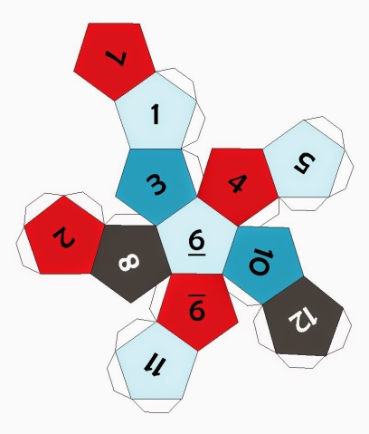
Cut apart, score the folds, and glue (or use glue gun) the 12-side dodecahedron die together.
Play
This game can be played with one player or many. It's easily adapted and can be played a number of ways.
Single Player Mean-Median Match-Up
The child rolls the die five times, recording the numbers rolled at the top of their recording card. When all six numbers have been rolled, they are put in order in the light blue boxes on the card from smallest to largest. Then the child finds both the mean of the numbers and the median. Which number is greater (mean or median)? That's the winner.
Note: It doesn't matter if two of the same number is rolled. Whatever number is in the middle spot on the card after the numbers are put in order, is the median.
Multiple Player Mean-Median Match-Up
Each player takes a turn with the die, rolling it five times, writing the numbers on their card and figuring out the mean and median of the collection of numbers. When all players are finished with their calculations, each will select the larger of the two numbers (either mean or median) on their card and ask their opponents to do the same. The player with the largest number wins the round.
Wipe the cards clean with a dry paper towel and get ready to roll and record six new numbers!
Play any number of rounds you'd like. This is a fun, fast-paced game that practices many math skills.

