Fraction Match (in the Grass) Card Game

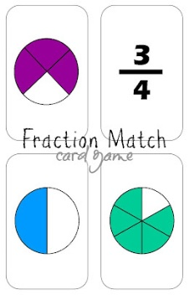

Here it is. And here's what you need to make it.
- Fraction cards –see template
- Heavyweight card stock to print the cards on (six sheets)
- Scrapbook paper imprinted with grass pattern (six sheets)
- Glue to adhere the scrapbook paper to the back of the card stock (I used spray glue)

Assembly
Print the cards on card stock. Glue the scrapbook paper to the back. Cut the cards out.

How to Play
Fraction Match is a modified “Go Fish” game. Deal each player six cards. Spread the remaining cards face-down (i.e. grass up) in between the players.

Each player lays their six cards face up in front of them in a row. If any of the cards represent the same fraction, they should be put together in one pile. In order for any match to be complete, the player must have THREE cards that represent the same fraction.

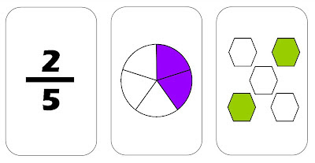
Every match has THREE cards.

Player 1 can either trade a singular card from their “hand” with an opponent or draw from the grass (the pile in the center). Note: Cards cannot be traded if a pile of two cards has already been started by the opponent (for example: ¾ and a pie with three of the four pieces colored in). Only single cards can be traded.

When a player has all three cards that make a fraction match, the pile is turned over to reveal the grass on the back of the cards.

Play continues back and forth between players until all the cards in front of one player have been matched, the piles have been turned over, and are therefore, all grass side face-up. This player wins!
Looking for a great book to pair with this activity? Read Loreen Leedy's Fraction Action!

