Equivalent Fractions Missing Numerator Board Game Instructions
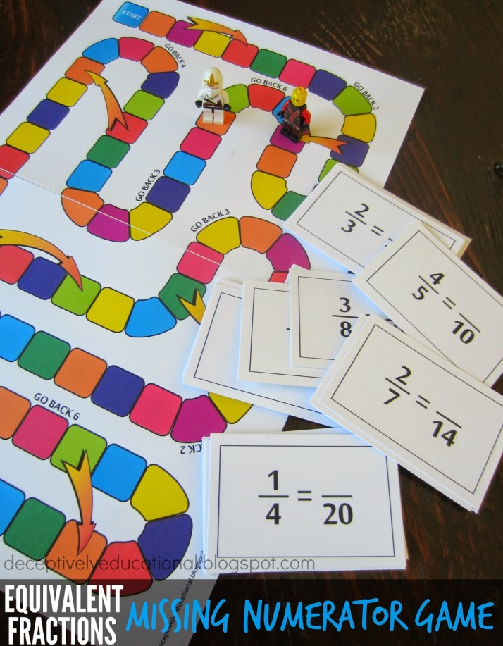
The game is simple. (Those always seem to be the most fun.)
Players advance around the game board by finding the missing numerator on playing cards printed with equivalent fraction equations.
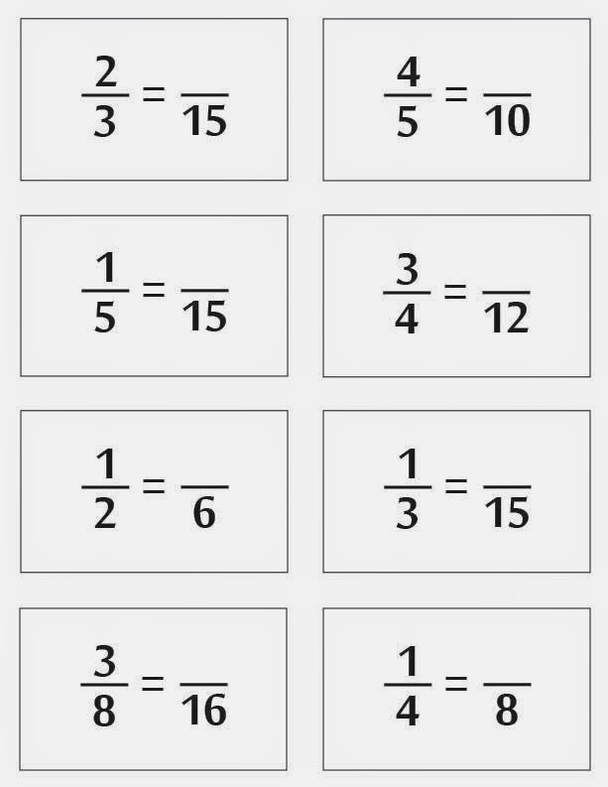
The missing numerator is the number of spaces the player moves.
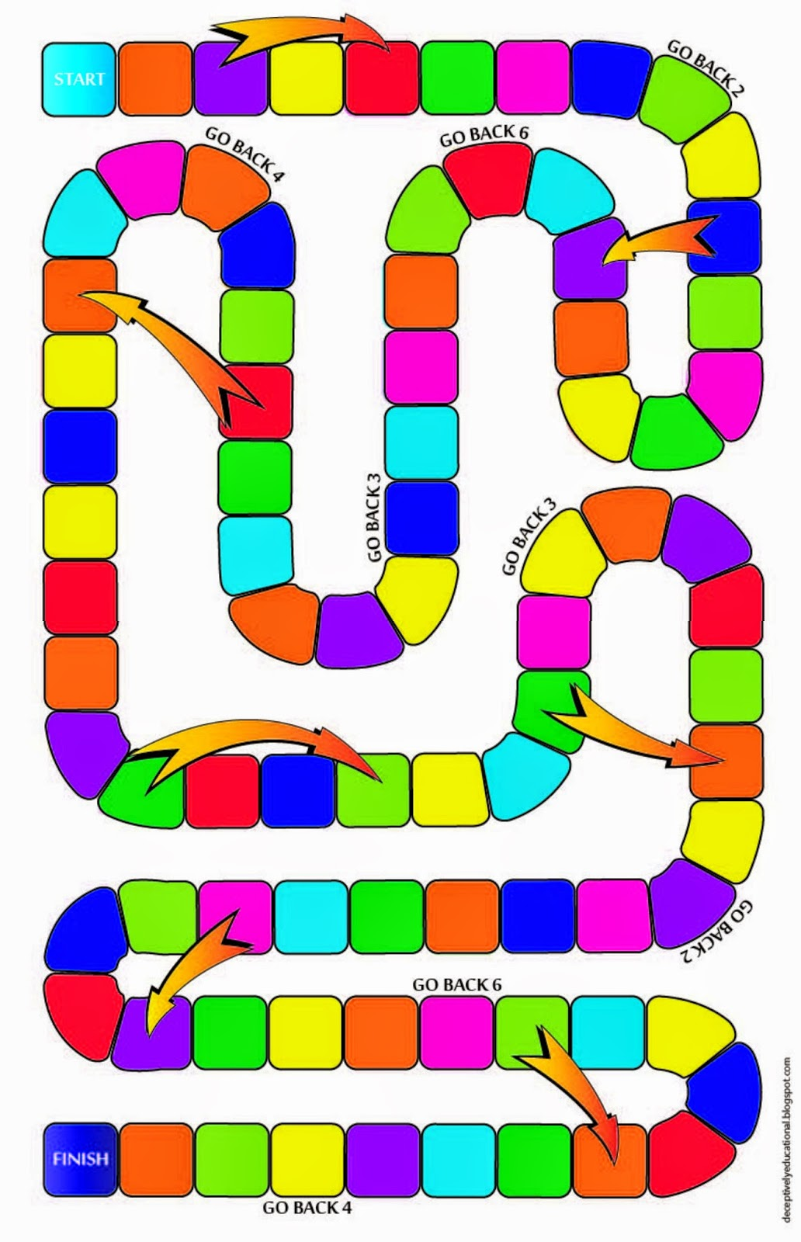
If they STOP (i.e. the last space in their count) on a space with GO BACK instructions, they must move toward the start the number of spaces noted.
If a player STOPs on a space that has the back-end of an arrow, they can follow the arrow and skip spaces on the board.
The first player to make it to the finish wins.

